To: | Finance and Performance Panel
Date: | 18 July 2024
Report of: | Head of Financial Services
Title of Report: | Comparative Analysis – Capital Slippage

Summary and recommendations
Purpose of report: |  | Brief: clearly and precisely setting out what the Committee is to approve and why.
Key decision: |  | No
Cabinet Member with responsibility: |  | Councillor Ed Turner, Deputy Leader (Statutory) and Cabinet Member for Finance and Asset Management
Corporate Priority: |  | All
Policy Framework: |  | Council Strategy 2020-24
Recommendation(s):That the Committee resolves to:
1. | Note and comment on the report and agree any recommendations.

Appendices
Appendix 1 | Capital Programme Slippage over the last 4 years

Introduction and background
- The Council’s capital programme has been significantly underspent over the last few years against the original budget approved by Members at February Council. Schemes are invariably slipped to the following year which invariably compounds the issue by increasing the capital programme for that year.
- During the preparation of the Medium Term Financial Plan for the following 4 year period commencing 1-4-2024 a ‘40% optimism bias’ was allowed for in the budget. This is a recognised adjustment to allow for the over optimism of a project management when planning and setting the budget for a capital project. The agreed budget is shown in the table below:

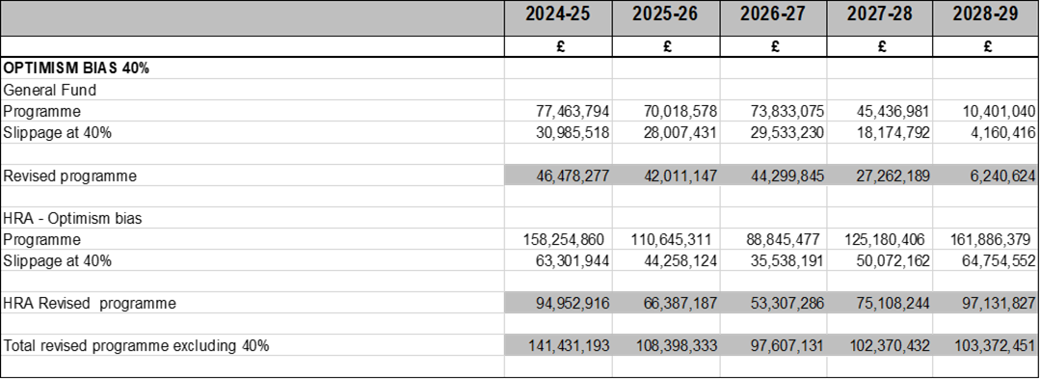

Update
- Appendix 1 shows the slippages on the Capital Programme over the last 4 years.
- It would be easy to assume that slippages are caused by poor programme management, lack of planning etc., but professional opinion would be more nuanced than this in the sense that many slippages on schemes are not all within our control.
- Salient points from this paper include:
- Slippages of the original capital budget plus prior year slippage over the 4-year period range between 52% and 76%. Specific schemes slipped in 2023-24 previously reported in monitoring include:
  - East Oxford Community Centre (£3.4m)
  - Covered Market (£2.2m) – delays from complexity of wider asset condition survey outside of masterplan project.
  - Oxford Flood Alleviation (£4.35m) – delay in processing funding agreement.
  - Osney Bridge (£4m) – objections from Environment Agency and planning approval.
  - Cowley Branch Line (£1.7m)
  - Blackbird Leys Community Centre (£8.4m) – financial viability has been a challenge due to increasing costs.
  - Northern Gateway – Oxford North (£10m) – not been possible to agree drawdown of funds and spend of HIF grant.
  - Affordable Housing Supply (£1m)
  - Loans To OxWED (£1.1m) – delay in obtaining planning approvals.
  - Motor Vehicles (£3.6m) – delays in processing orders for vehicles due to evaluation of EV requirement.
- Slippages on General Fund activity (excluding activities linked to OX Place) range from 49% to 79%.
- Slippages on General Fund activity linked to loans to OX Place run at 100%. Loans to OX Place are linked to the cashflow activities of the company to meet its financial commitments to meet its development and acquisition programme. The Council has struggled in prior years to obtain accurate forecasts of company cashflows, although improvement is expected going forward with quarterly business plan updates having been agreed with the company.
- Slippage on HRA schemes (excluding acquisition of houses from OX Place) ranges between 6% and 88%. This is directly linked to the OX Place programme and shows an increasing slippage as the year progresses. Slippage in the company programme may impact on dividend returns to the Council.

- In conclusion, there will always be delays in development programmes whether this is with those projects in direct delivery by the Council or indirectly through the OX Place development programme, even though officers try to mitigate this. The Council has, perhaps optimistically, put a 40% optimism bias in the 4 year programme when it set its budget in February 2024. This was on the expectation that there may be an improvement in the amount of slippage; although whether this happens remains to be seen.

Report author | Nigel Kennedy
Job title | Head of Financial Services
Service area or department | Financial Services
Telephone | 01865 252708
e-mail | nkennedy@oxford.gov.uk

Background Papers: None

